DBMS Practical file

Name: Mohammed Hashim Bin Yahya

Roll no:20221429

Course: B.sc Computer science

Q1: I. Create and use the following student-society database schema for a college to answer the given (sample) queries using the standalone SQL editor.

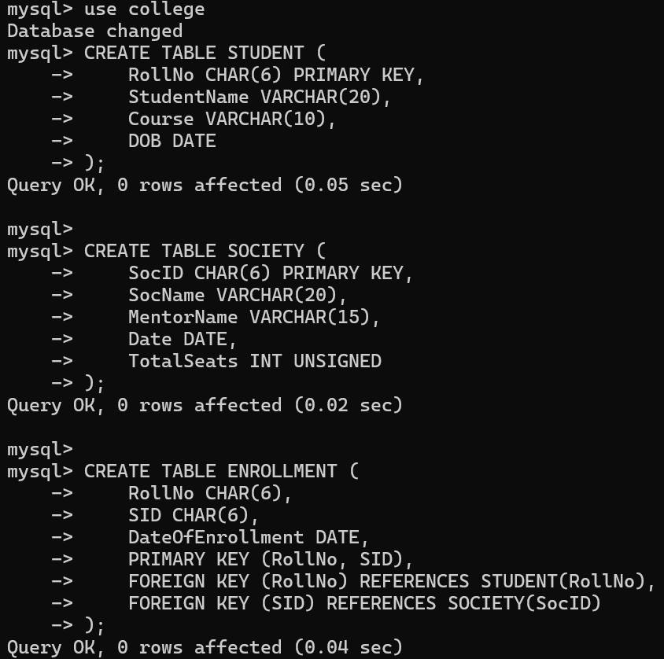

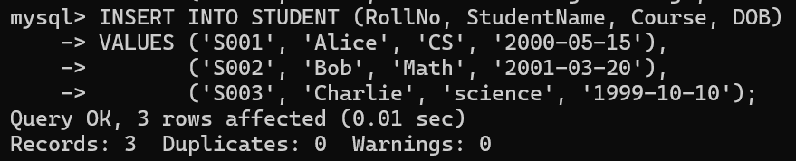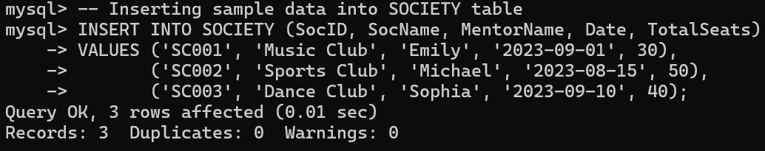

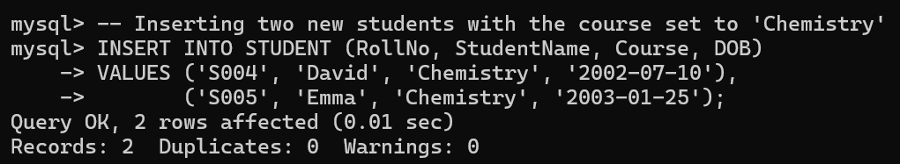

Query 1: Retrieve names of students enrolled in any society.

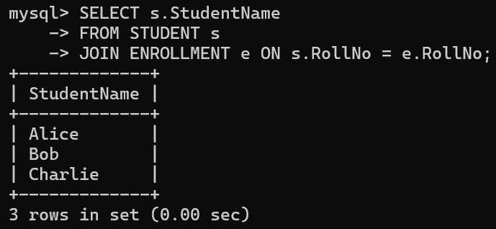

Query 2: Retrieve all society names.

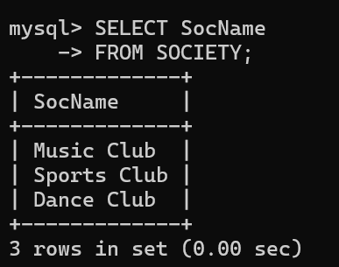

Query 3: Retrieve students' names starting with letter ‘A’

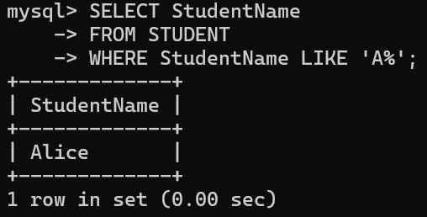

Query 4: Retrieve students' details studying in courses ‘computer science’ or ‘chemistry’.

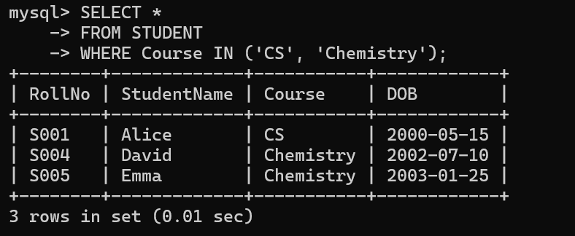

Query 5:

Retrieve students’ names whose roll no either starts with ‘X’ or ‘Z’ and ends with ‘9’.

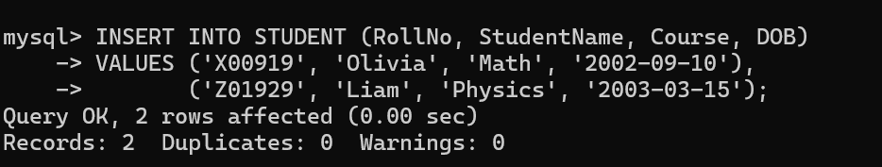

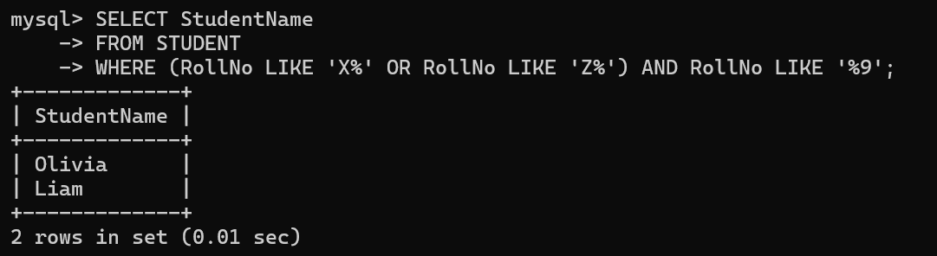

Query 6: Find society details with more than N TotalSeats where N is to be input by the user.

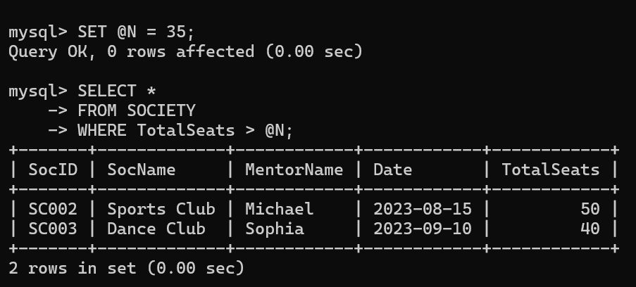

Query 7: Update society table for mentor name of a specific society

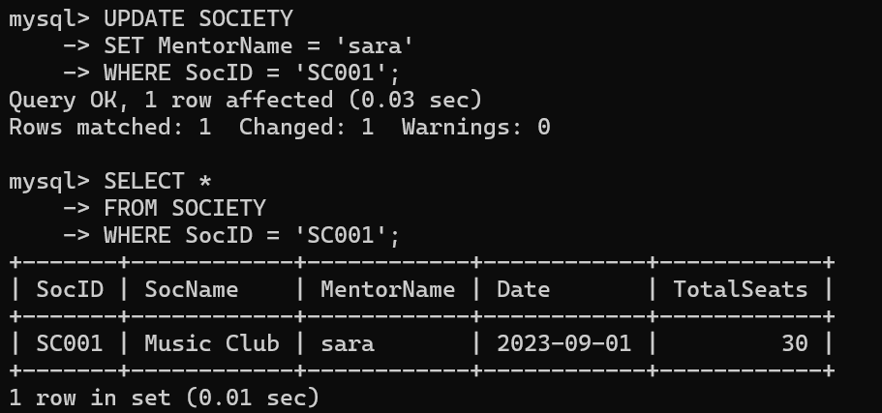

Query 8: Find society names in which more than five students have enrolled.

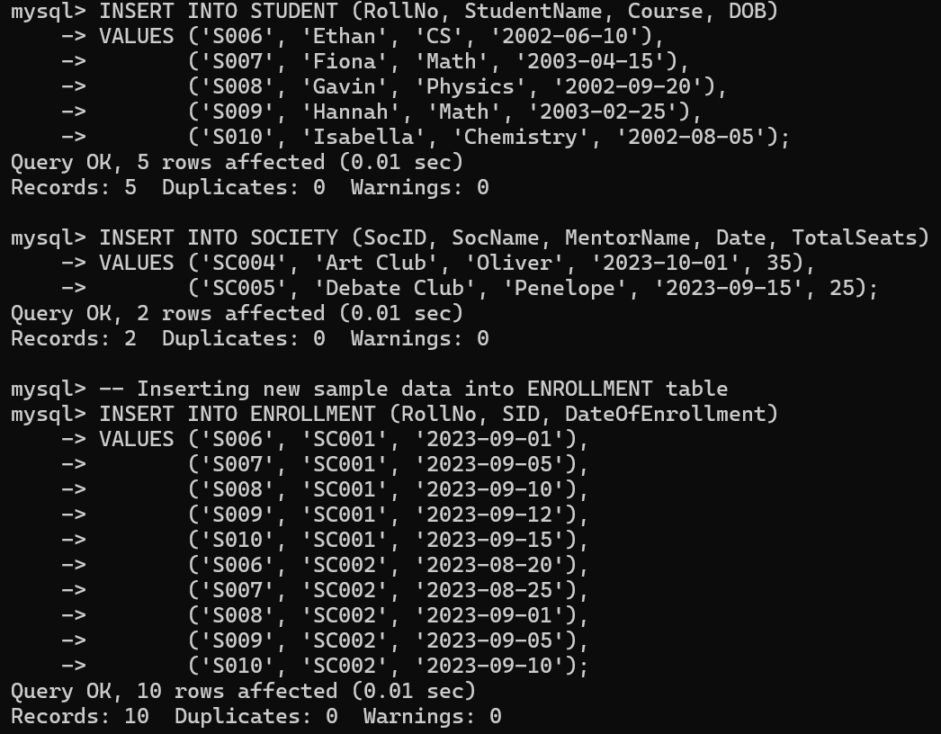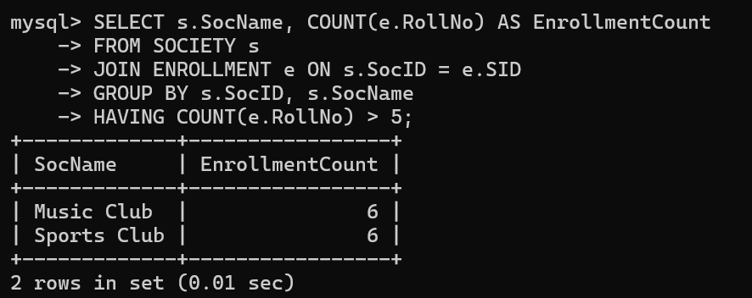

Query 9: Find the name of youngest student enrolled in society ‘music club’

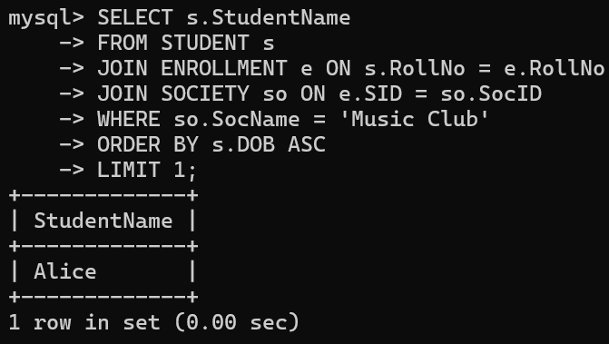

Query 10: Find the name of most popular society (on the basis of enrolled students)

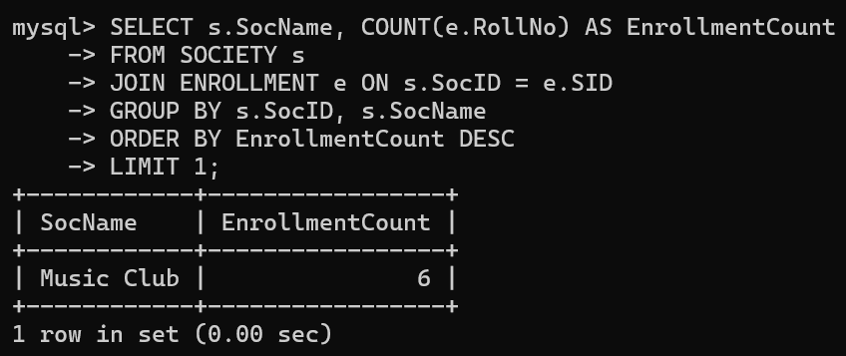

Query 11: Find the name of two least popular societies (on the basis of enrolled students)

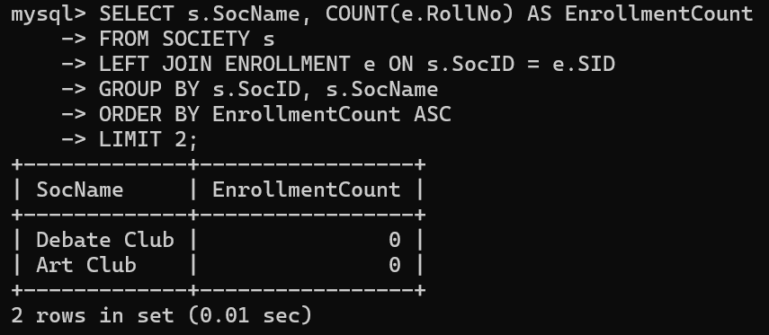

Query 12: Find the student names who are not enrolled in any society

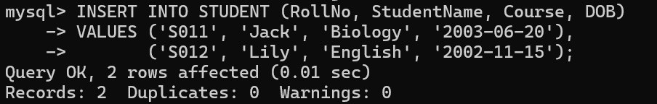

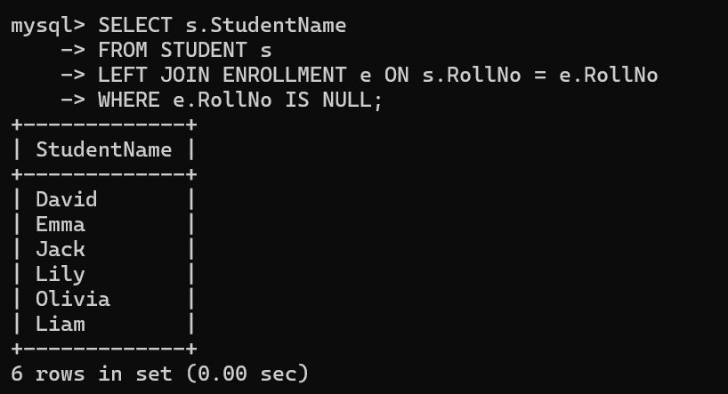

Query 13: Find the student names enrolled in at least two societies

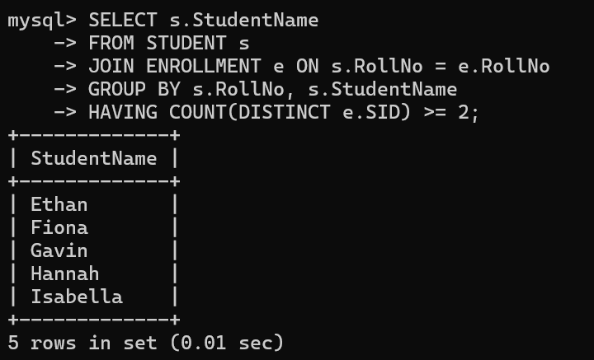

Query 14: Find society names in which maximum students are enrolled

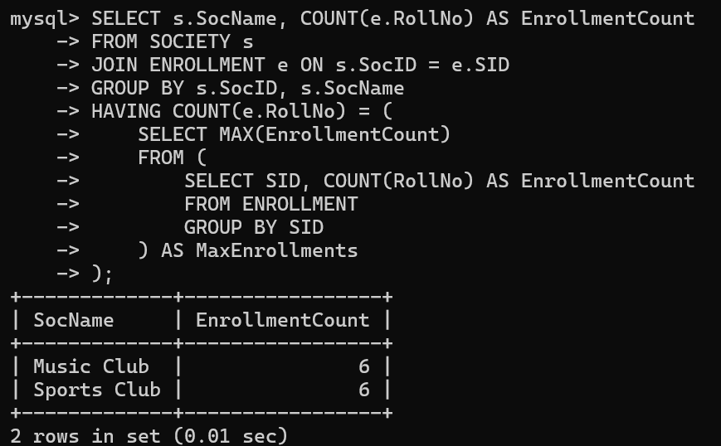

Query 15: Find names of all students who have enrolled in any society and society names in which at least one student has enrolled

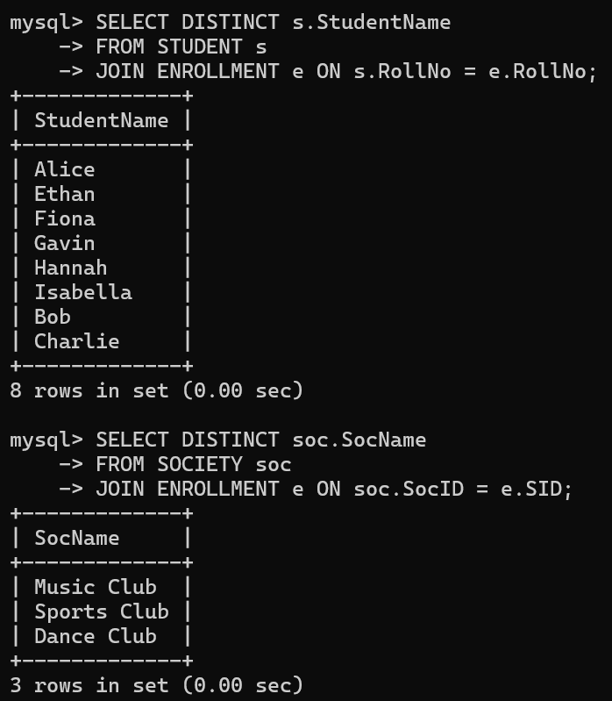

Query 16: Find names of students who are enrolled in any of the three societies ‘Debating’, ‘Dancing’ and ‘music’

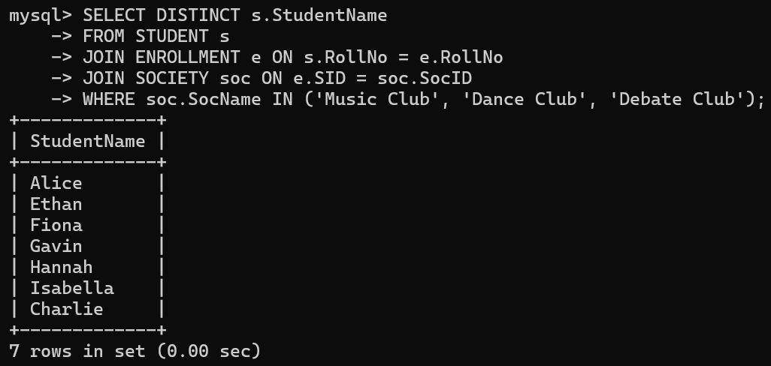

Query 17: Find society names such that its mentor has a name with ‘’ in it.

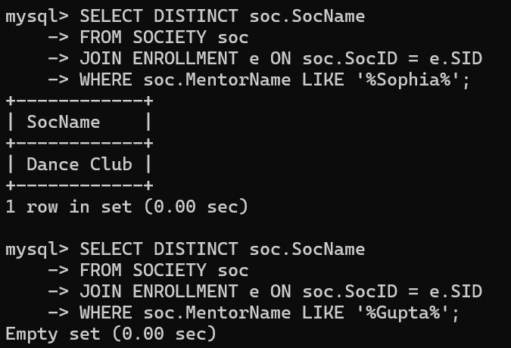

Query 18: Find the society names in which the number of enrolled students is only 10% of its capacity.

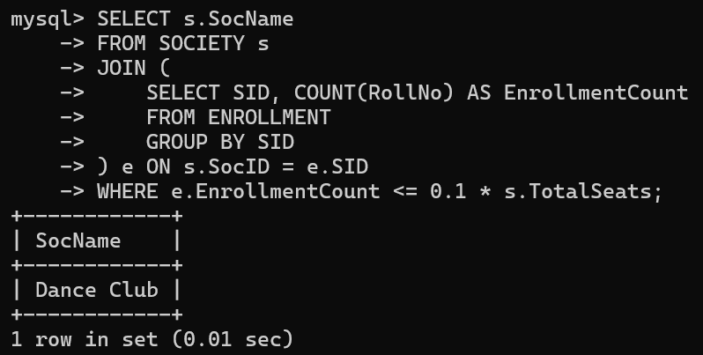

Query 19: Display the vacant seats for each society.

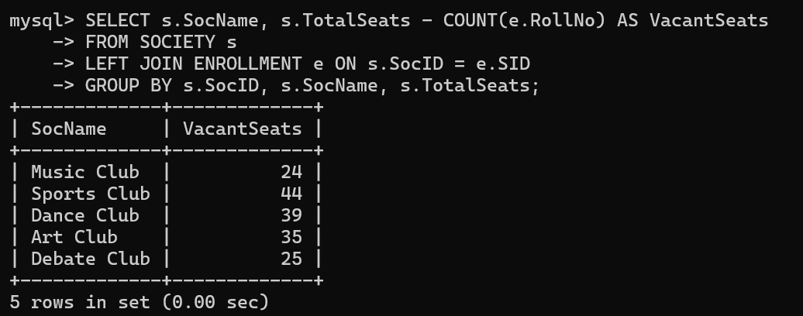

Query 20: Increment Total Seats of each society by 10%

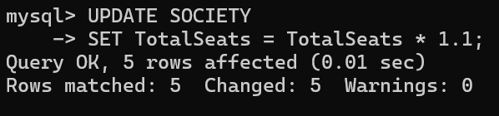

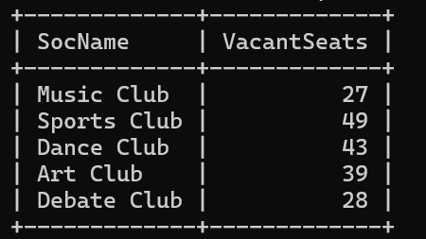

Query 21: Add the enrollment fees paid (‘yes’/’No’) field in the enrollment table.

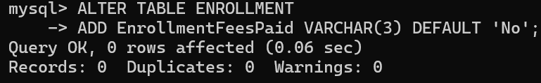

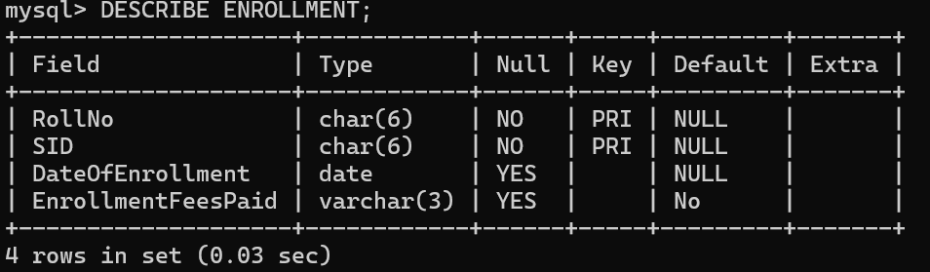

Query 22: Update date of enrollment of society id ‘s1’ to ‘2018-01-15’, ‘s2’ to current date and ‘s3’ to ‘2018-01-02’.

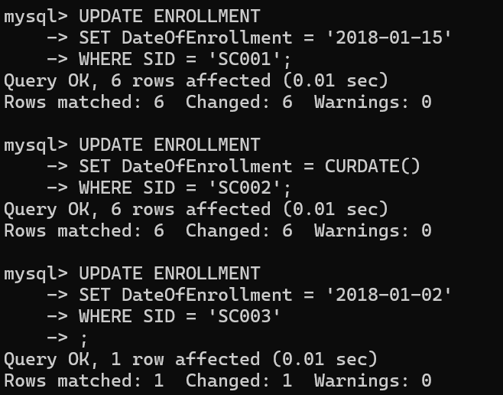

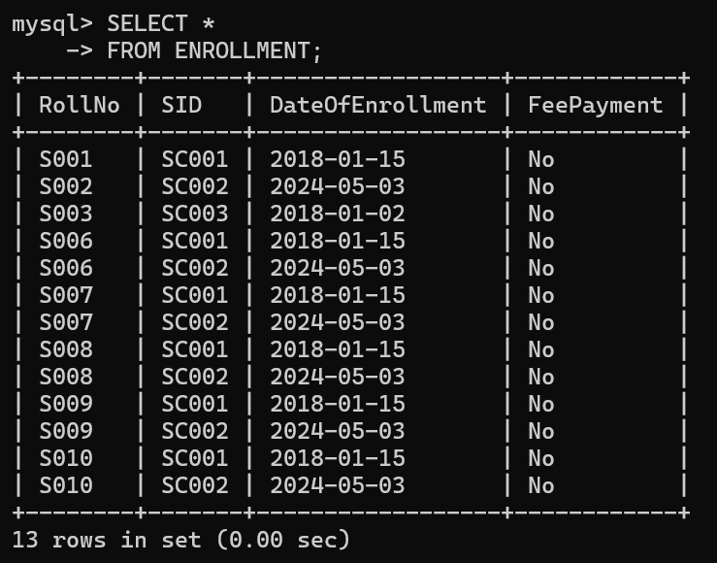

Query 23: Create a view to keep track of society names with the total number of students enrolled in it.

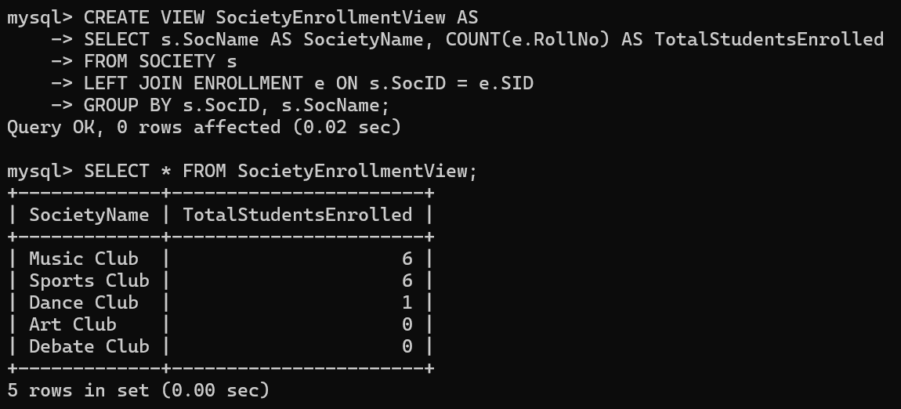

Query 24: Find student names enrolled in all the societies.

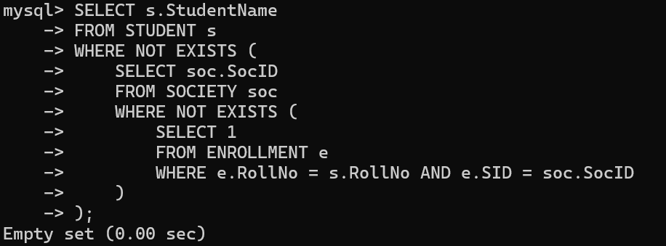

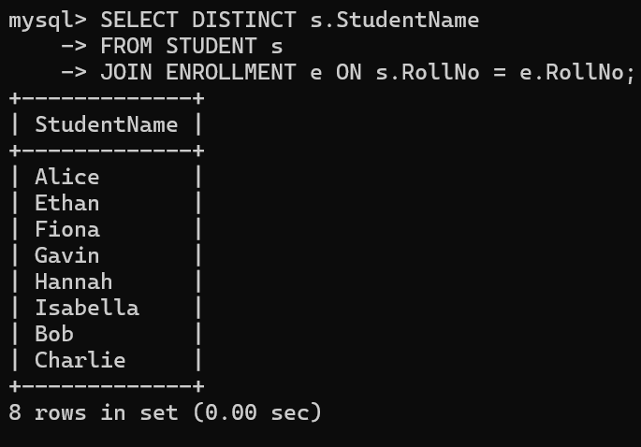

Query 25: Count the number of societies with more than 5 students enrolled in it

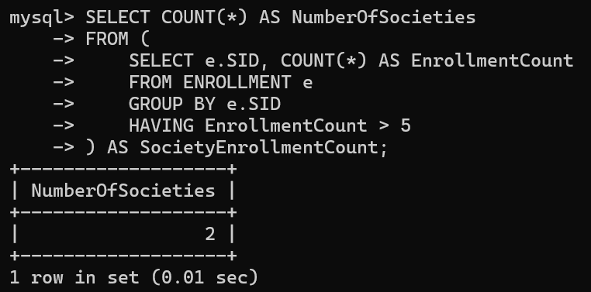

Query 26: Add column Mobile number in student table with default value ‘9999999999’

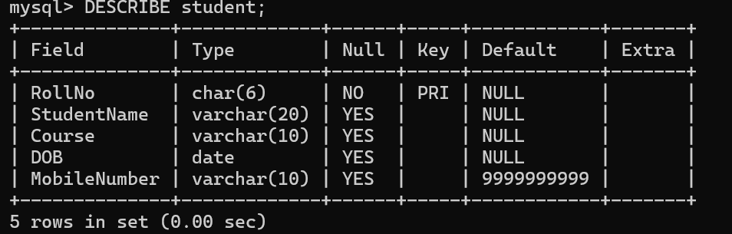

Query 27: Find the total number of students whose age is > 20 years.

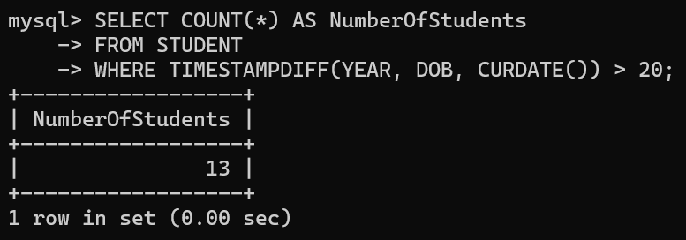

Query 28: Find names of students who are born in 2001 and are enrolled in at least one society.

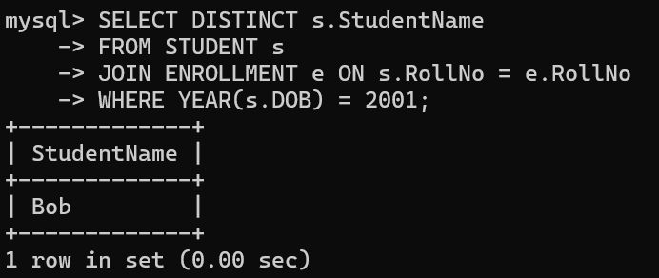

Query 29: Count all societies whose name starts with ‘S’ and ends with ‘t’ and at least 5 students are enrolled in the society.

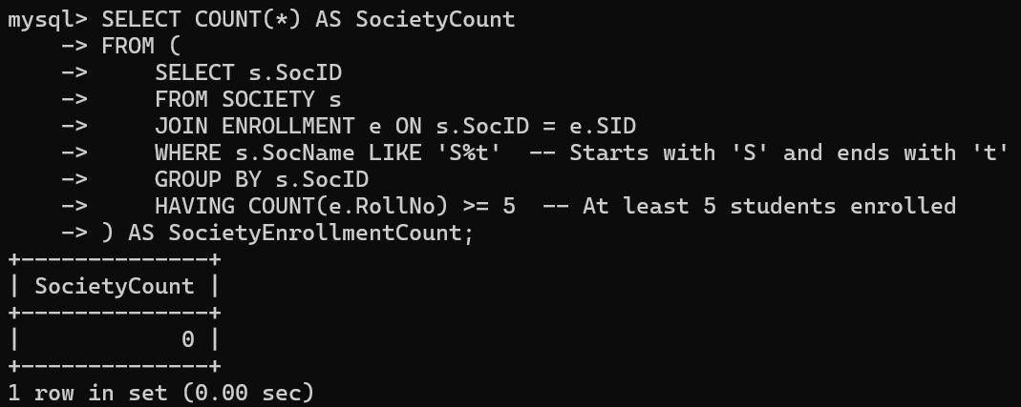

Query 30: Display the following information: Society name Mentor name Total Capacity Total Enrolled Unfilled Seats

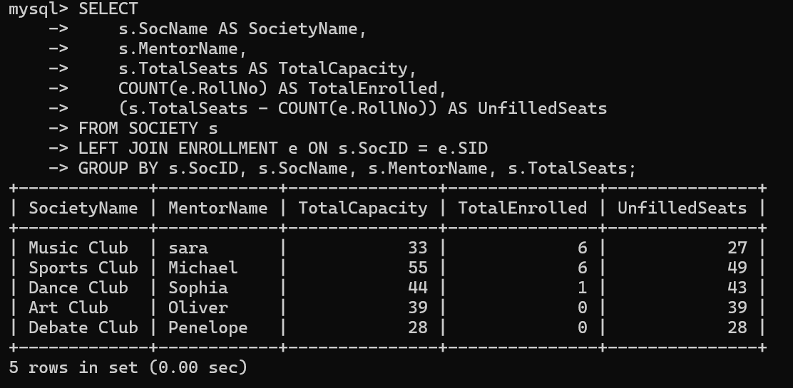

Q2: Do the following database administration commands: create user, create role, grant privileges to a role, revoke privileges from a role, create index

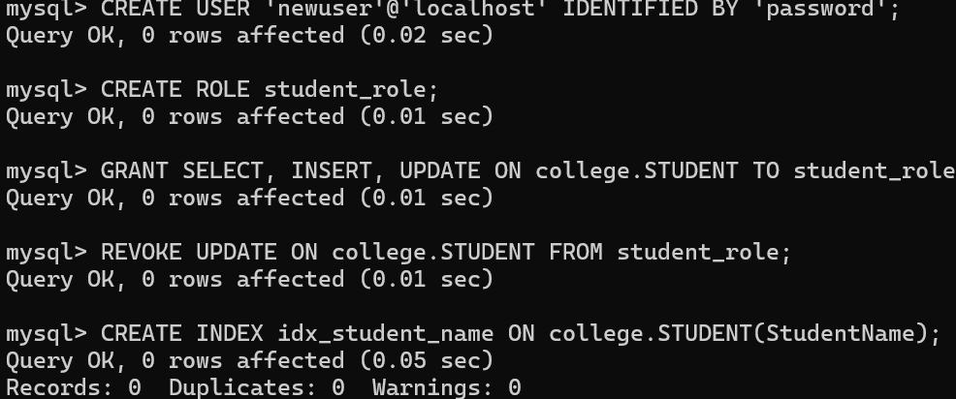

Q3: Execute queries given in part I through a high-level language using ODBC connection.

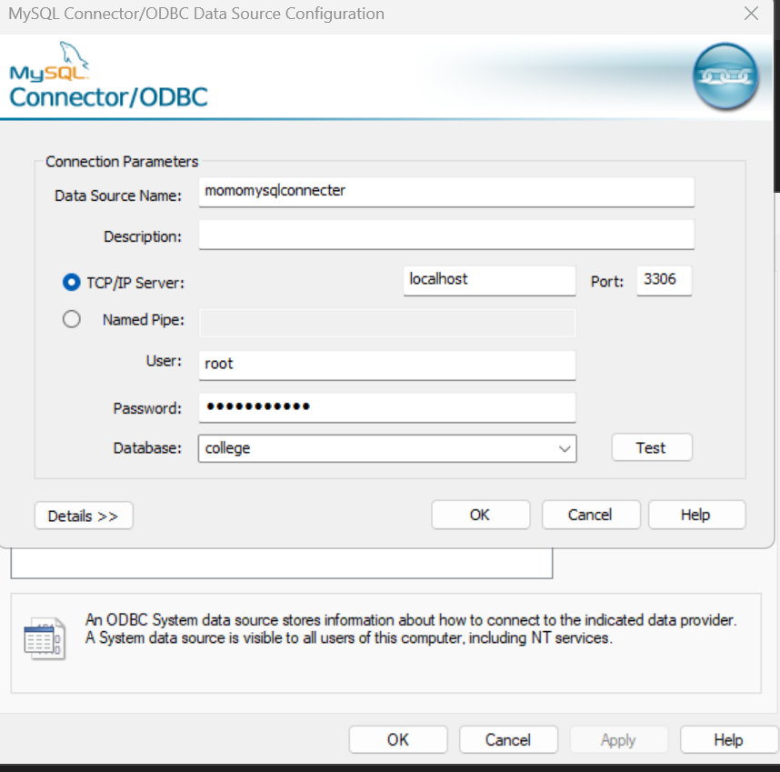

**The code:**

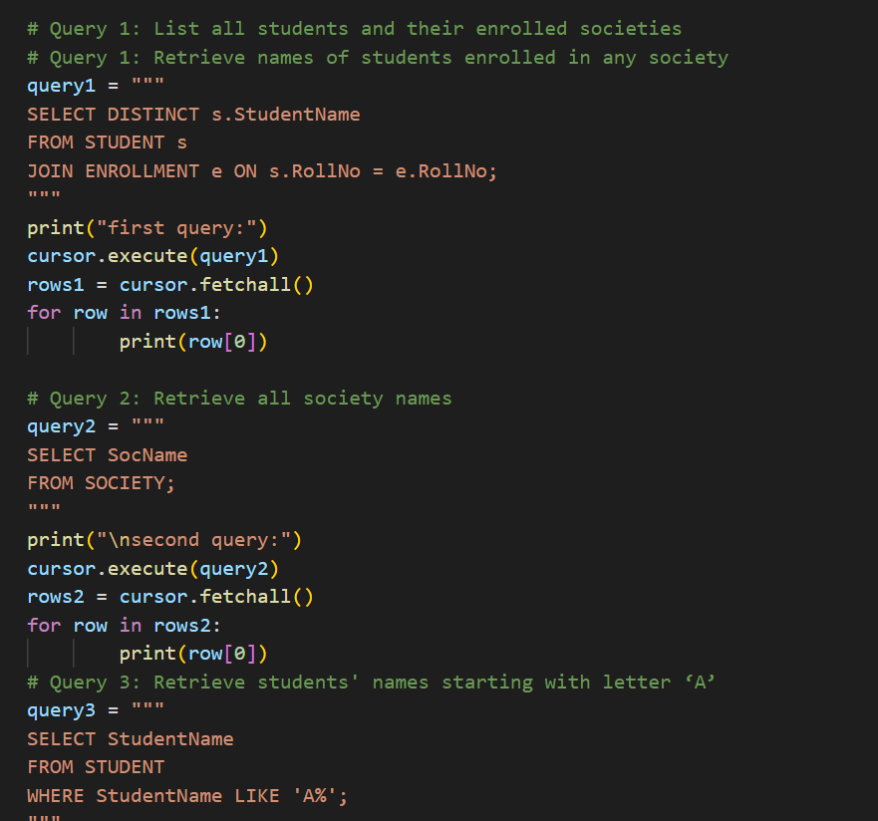

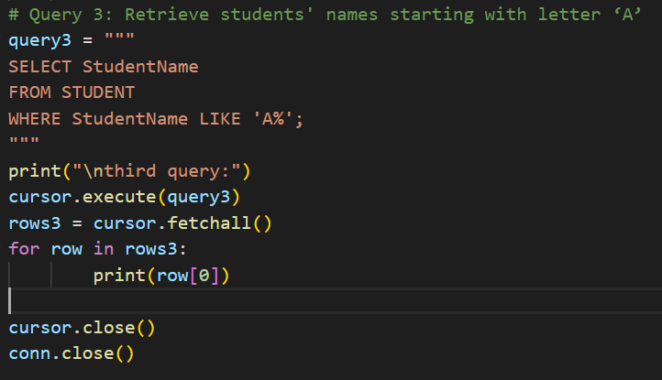

**The output:**

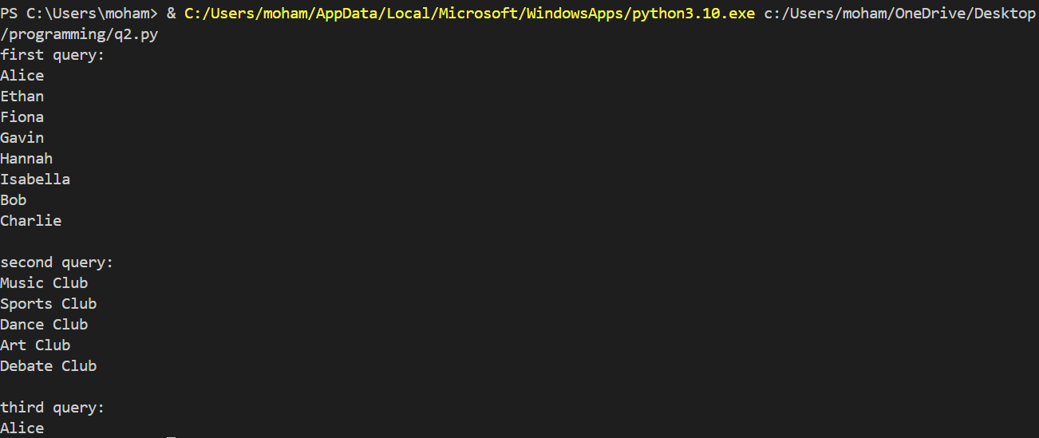

Q4: Students should implement the COMPANY database schema from Chapter 3 [1] and execute the solved queries of Chapter 7 [1].

